**Task 2: Figma Screens**

**The Figma Screens are done here in this file:**

1. **Screen 1: Homepage**

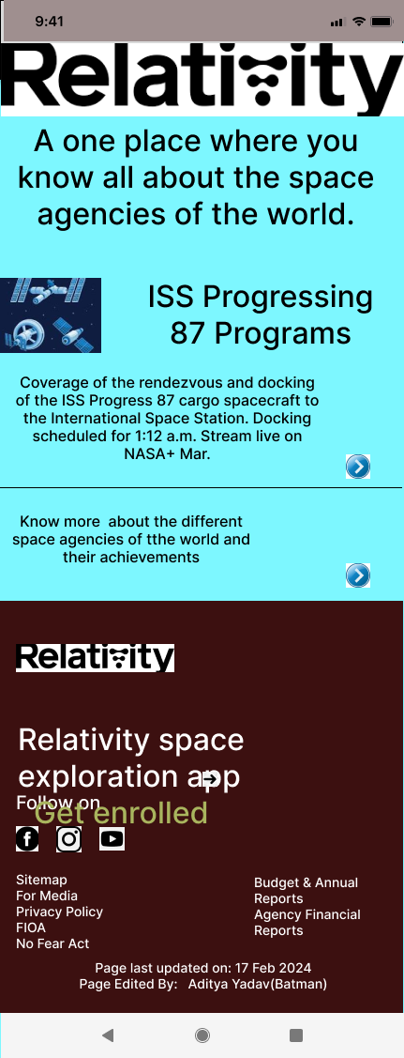

1. **Screen: Description**

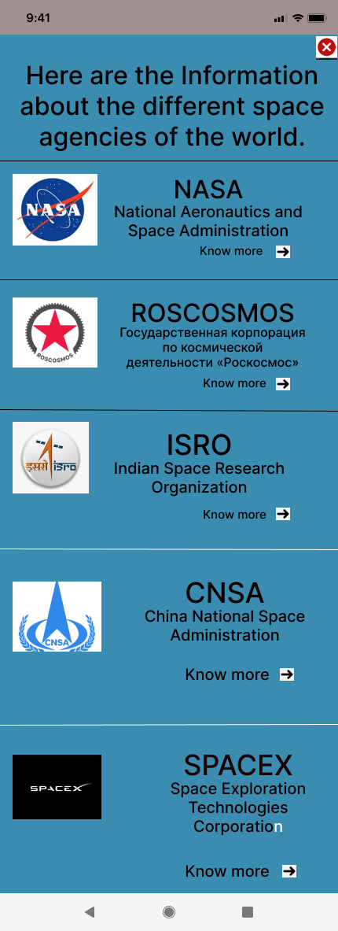

1. **Screen : NASA**

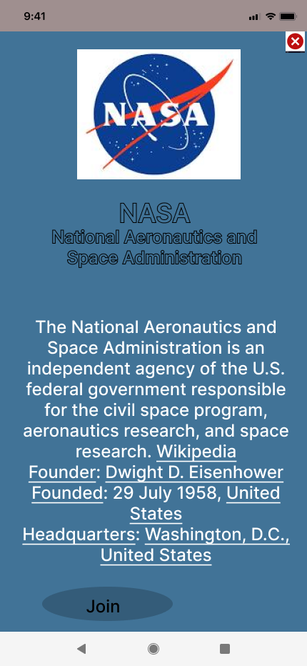

1. **Screen : ROSCOSMOS**

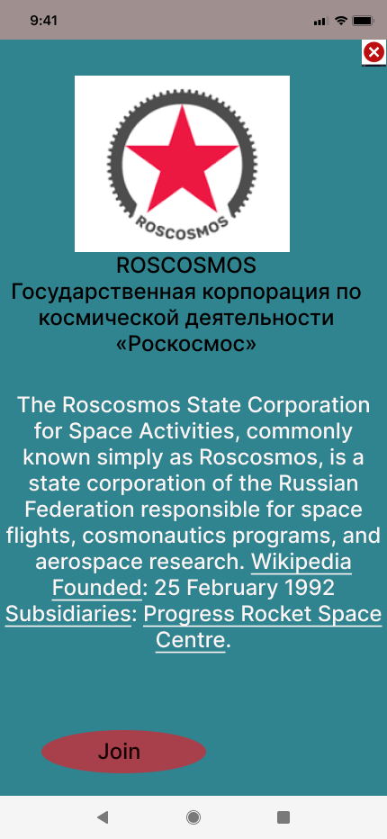

1. **Screen ; ISRO**

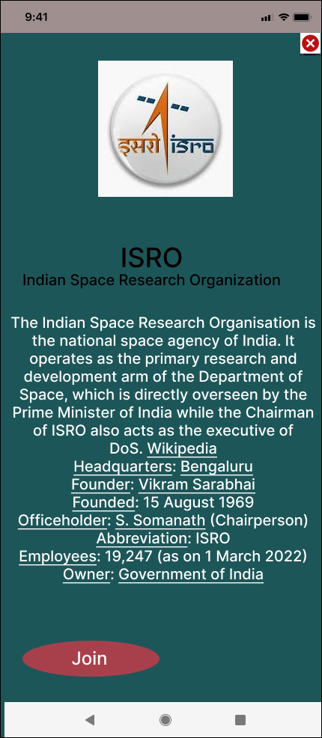

1. **Screen : CNSA**

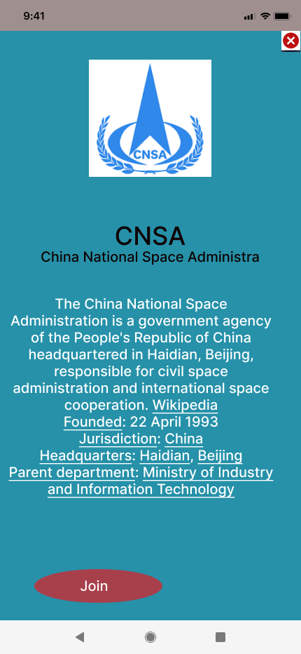

1. **Screen : SPACEX**

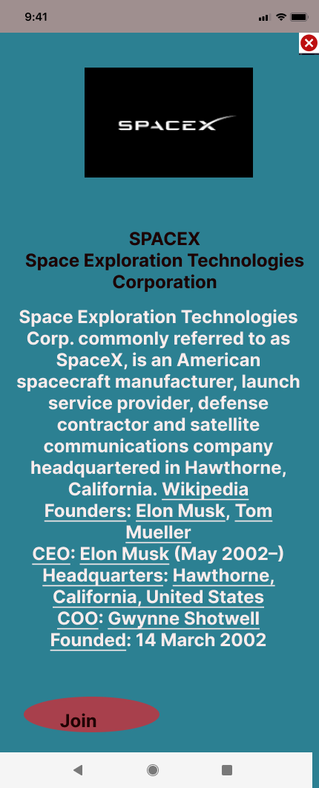

1. **Screen : International Space Station**

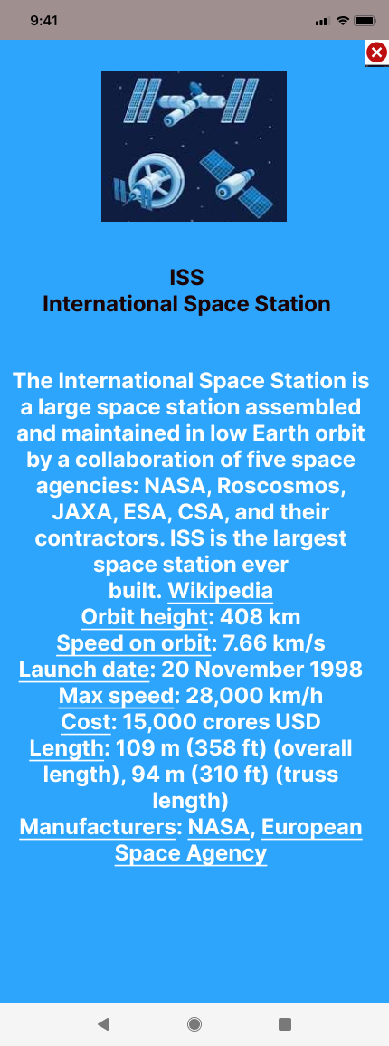

**These are all the screens used to make the mobile application named Relativity Space.**

**To make the prototype for the application make it artistic, professional and design oriented.**